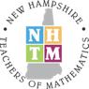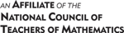

March 12, 2021
The New Hampshire Teachers of Mathematics would like to thank the following sponsors for their generous support of the NHTM March 18, 2021 Annual Spring Conference.

Gold-Level Sponsors: Each Gold-level sponsor will be providing a workshop from 7-8 pm. Please consider attending one of these workshops.

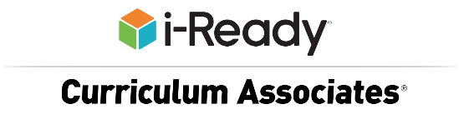

Addressing learning loss among all students for all students will be a top priority in the coming months as districts prepare for summer school and back to school 2021.
Please join Curriculum Associates to learn how our programs were designed based on the principle that when students take ownership of their learning, they progress at a faster rate and are motivated to achieve. We believe that data can be transformative in making this happen. When educators can combine a deeper knowledge of students’ individual needs with effective and engaging instruction and practice that addresses these specific needs, they are best able to support students and help them make progress toward proficiency and growth.

https://www.curriculumassociates.com/
Julie Armitage jarmitage@cainc.com
Phone (207) 749-3677

CODING FOR ALL! Let's get ALL students coding with a fun, low floor-high ceiling activity. No experience needed! Learn how I incorporated coding into all of my HS math classes ~ from Alg 1 to AP Stats. Free resources will be shared.

www.ti.com
Robyn Poulsen rpoulsen@ti.com
Phone (518) 569-4120

Topic: Math Solutions for Today’s Learning Environment

Our Mission
We support teachers, inspire students, engage parents, and champion learning by doing. Make an impact on student learning! Here at hand2mind we believe children learn best by doing. For over 50 years, teachers and administrators at thousands of schools and districts across the country have relied on our high-quality, hands-on materials to expand their core curriculum. From math to science to STEM to literacy and from manipulatives to lessons to teacher/parent support materials, we’re always on the lookout for new ways to get students’ hands and minds working together.

https://www.hand2mind.com
Greg Cantone gcantone@hand2mind.com
Phone (508) 849-7346

Silver-Level Sponsor: Our Silver-level sponsor will be providing a workshop from 7-7:30 pm. Please consider attending this workshop.

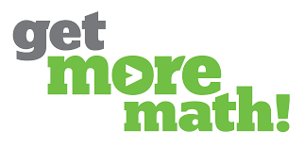

By the end of the school year, students have already forgotten many of their hard-won math concepts and skills. How can we make it stick? Josh Britton will share his 20-year journey, proven model, and custom-created Get More Math system for driving long-term math retention in the classroom.

Get More Math provides a results-oriented and web-based program designed to improve initial mastery and long-term retention of all math skills for grades 3rd through high school and NEVER replaces the teacher in the classroom. With built-in printable & downloadable worksheets, cumulative exams (with formative and summative assessments), real-time data reports for teachers and administrators, and Clever SSO integration, Get More Math is FREE through July 2022 for new schools, educational service centers (ESCs), afterschool programs, summer programs, and non-profit organizations. Secure your free trial at: www.GetMoreMath.com today!!!

www.GetMoreMath.com
Tony Gonzales tgonzales@getmoremath.com
Mobile Phone: (814) 322-2516
To Schedule a 15-Minute Discussion:
https://calendly.com/tonygetmoremath/15-min
Free School Year Trial of Get More Math:
https://getmoremath.com/trial/

Bronze-Level Sponsor: Please consider supporting our local New Hampshire Publishing Company.

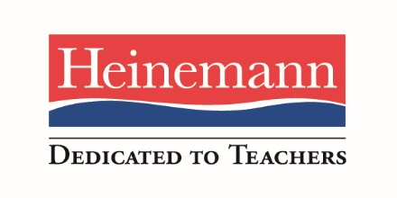

For over forty years Heinemann has been a publisher of professional resources and a provider of educational services for teachers, kindergarten through college. Our authors are exemplary educators eager to support the practice of other teachers through books, videos, workshops, online courses, and most recently through explicit teaching materials. Our commitment to our work and customers’ enthusiastic response to our offerings has made us the leading publisher in this area.

www.heinemann.com
Karen Cook
karen.atwood.cook@gmail.com
603-662-0210 (home office/fax)
207-522-0761 (cell)

Heinemann Virtual PD Offerings
Current topics & new titles from Booksource!
New Early Reader K-2 series from Crabtree!

Platinum-Level Sponsor: Sister Paula Marie Buley, IHM
Rivier University President

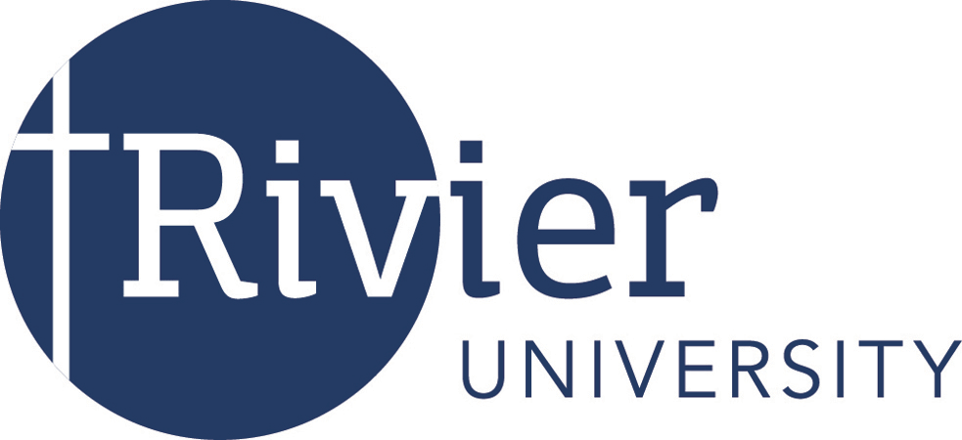 “Transforming Hearts and Minds to Serve the World.”

A very special thanks to Rivier University for providing the Zoom Platform to host this conference and to Todd Kent for his technical support.

Rivier University in Nashua, NH prepares undergraduate and graduate students for rewarding careers in Mathematics and Mathematics Education. With a Rivier degree, you will have the skills and knowledge for a variety of in-demand careers as well as advanced study and research. Explore our academic programs at www.rivier.edu/programs.

